**Soccer League Database Design Document**

**Version 1.1**

**Submittal Date: 09/12/2021**

|  |  |
| --- | --- |
| Version | Description |
| 1.0  1.1 | First release draft  Added Relation Schema |

**Table of Contents**

**Topic Page**

**Purpose…………………………………………………………………………………………4**

**Narrative……………………………………………………………………………………….4**

**Requirements (Actors/Roles)………………………………………………………………….6**

**Entities………………………………………………………………………………………….6**

**Entities(w/ Nested Attributes)………………………………………………………………7-8**

**Business Rules…………………………………………………………………………………..9**

**ERD……………………………………………………………………………………………..10**

**EERD……………………………………………………………………………………………11**

**Purpose** – The purpose of this DBDD is to create formulate a diagram in which connects all of the Soccer league entities together .

**Narrative** - The soccer league administrator wants to create a database to track teams, players, coaches, matches, fields, vendors, referees, and sponsors.

Reports include: match scores and results, player stats, referee assignments, team rosters, field and team sponsors, vendor types and field assignments, and coach assignments.

The soccer league consists of teams. Teams have one or more sponsors whose names appear on the team uniforms. Sponsors can support more than one team, and a team may have more than one sponsor at a time. Sponsorships are tracked by season.

Each team consists of players. No player belongs to more than one team during a single season. Each player is assigned a unique Player ID when they join the league. The league records each player’s name and address, parent contact name, player phone number and parent phone number, and parent email. In order to verify players ages, the league also records each player’s date of birth. Each team has a designated captain from among the players. Players are registered for the league followed by a draft to receive their team assignments. Players can play for one team one season and then play for a different team the next season.

Teams play in matches. Each match is given a unique Match ID number and is scheduled for a specific date. The league records the goals scored by each team and the win or loss result.

Player performance in each match is recorded for minutes played, goals scored, and penalties assessed. It is possible for a player to not participate in a match.

The league assigns three referees to each match, based on position (one head (H) and two linesmen (L)). Referees are assigned a unique Referee ID number when they first register with the league. The league records each referee’s name (first name and last name), address and phone number, and contact email. Each new referee is assigned to one experienced referee as a mentor. Not all of the experienced referees serve as mentors, but those that do can mentor more than one new referee.

Matches take place at soccer fields. Sponsors can support fields by placing banners. Sponsors can support more than one field, and fields can have more than one banner. The league records the name and address (street, city, state, and zip) of all the fields where it stages matches. Each match, occurs at a single field at a time. The fields host multiple matches throughout the season. Some fields are closed when undergoing renovations with no matches scheduled during that period.

Vendors sell items at specific fields. Each field has several vendors. The league tracks the vendor assignments by season. In addition to the vendor’s name, the league records the vendor phone number and the vendor type. Some vendors offer multiple types of services, for example: food, beverage, clothing, soccer suppliers, and other items.

The league also tracks coaches. A coach can be assigned to more than one team, but only as one role per assignment. Coaching roles are head (HC), assistant (AC), volunteer (VC). Each team can have multiple coaches, but only one role at a time may be assigned to a single coach. Coach assignments are based upon season

**Requirements (Actors and Roles)**

**Teams –** Teams have players they are they are a group of players

**Players -**Players are the ones playing the games

**Matches-** Matches are created so that teams are able to play against one another

**Fields –** Fields are what the players play on .

**Vendors-** Vendors are at fields and sell items / services during games.

**Sponsors-** Sponsors are for teams , they are the advertisement for those teams.

**Coaches-** Coaches are assigned to teams and there can be multiple coaches on a team

**Referees** – Referees are the one that’s that oversee the games . Fouls , Penalties , etc.

**Entities**

* **Teams**
* **Players**
* **Matches**
* **Fields**
* **Vendors**
* **Sponsors**
* **Coaches**
* **Referees**

**Entities w/Nested Attributes**

* **Players**
  + **PlayerID**
  + Name
  + Address
  + Parent Contact Name
  + Player Phone Number
  + Parent Phone Number
  + Parent Email
  + Date of Birth (DOB)
* **Team**
* **TeamID**
* PlayerID
* **Matches**
* **MatchID**
* Scores
* Results
* Dates
* Player Statistics
* **Fields**
* **FieldID**
* Name
* Address
* **Vendor**
* **VendorID**
* Name
* Phone Number
* Vendor Type
* **Sponsor**
* **SponsorID**
* Name
* Season
* **Referee**
* **RefereeID**
* Name
* Address
* Phone Number
* Email
* **Coach**
* **CoachID**
* Name
* Season

**Business Rules** :

Teams – Teams can have multiple players . Nothing is stated about a team not having players.

Players – Players can only be assigned to one team person season . Players play on fields and have matches .

Matches – There can only be one match going on at a time per field .

Field – a field can have multiple matches throughout the day but only one match can be played at a time

Referees – Referees can be mentored by other experienced referees , referees can be assigned to another referee , some referees don’t have mentors .

Sponsors – Sponsors are on fields and place banners for their associated teams. Teams can have multiple sponsors and sponsors can have multiple teams Sponsors get assigned on a season basis.

Vendor – Vendors are at the fields . There can be multiple vendors in a field . Vendors sell items

Coach – Coaches are assigned to teams . Coaches can be assigned can only be assigned to one role at a team but can be assigned to different teams . Coaches are assigned on a seasonal basis. There can be multiple coaches on a team.

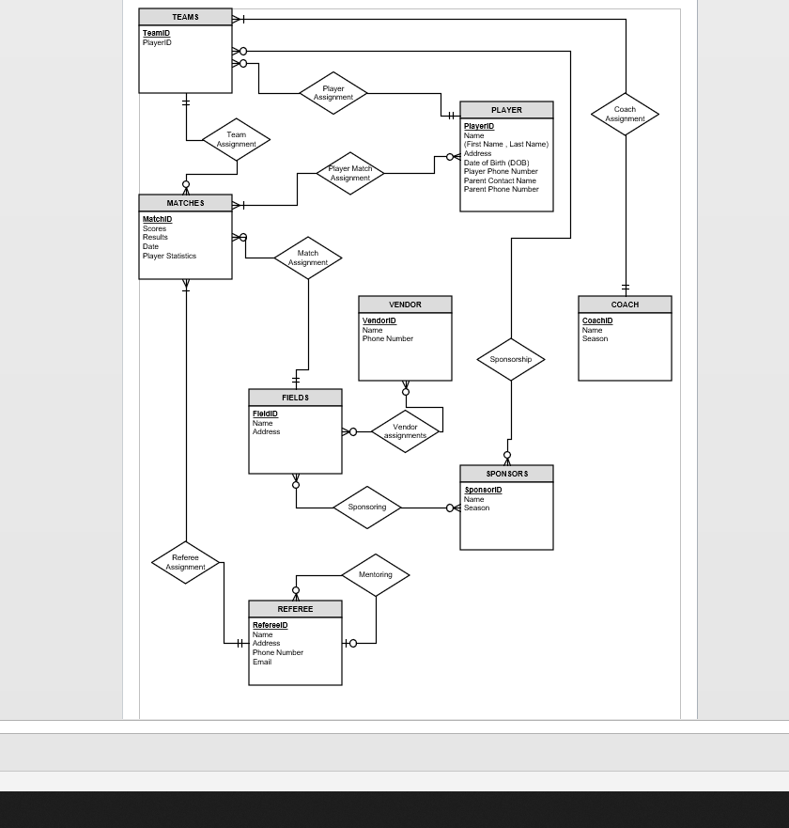ERD DIAGRAM

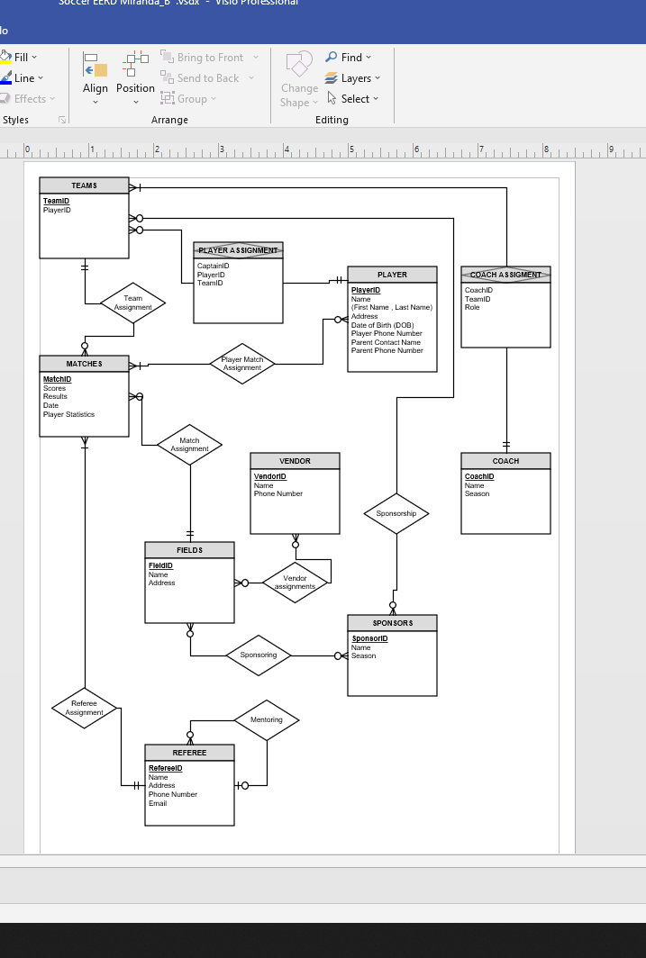EERD DIAGRAM

SOCCER LEAGUE RELATION SCHEMA

